1. What is functional testing and non-functional testing?

| **Functional Testing** | **Non Functional Testing** |
| --- | --- |
| It tests ‘What’ the product does. It checks the operations and actions of an Application. | It checks the behavior of an Application. |
| Functional testing is done based on the business requirement. | Non- functional testing is done based on the customer expectation and Performance requirement. |
| It tests whether the actual result is working according to the expected result. | It checks the response time, and speed of the software under specific conditions. |
| It is carried out manually. Example: Black box testing method. | It is more feasible to test using automated tools. Example: Loadrunner. |
| It tests as per the customer requirements. | It tests as per customer expectations. |
| Customer feedback helps in reducing the risk factors of the product. | Customer feedback is more valuable for non- functional testing as it helps to improve and lets the tester to know the expectation of the customer. |
| It is testing the functionality of the software. | It is testing the performance of the functionality of the software. |
| Functional testing has the following types: •Unit testing •Integration testing •System Testing •Acceptance Testing | Non functional testing includes: •Performance testing •Load Testing •Stress testing •Volume testing •Security testing •Installation testing •Recovery testing |
| Example: A Login page must show textboxes to Enter the username and password. | Example: Test if a Login page is getting loaded in 5 seconds. |

1. What are Pre conditions for Facebook login page before writing the test cases?

Most important documents needed to write the test cases are the SRS, BRD and user cases. SRS contains all the software requirements for the release and BRD contains the business requirements.  These two is very helpful in writing test cases and ensures that test cases related to system and business is met.

3 . What are Testing principles?

* Testing shows the presence of defects
* Exhaustive Testing is not possible

Sometimes it seems to be very hard to test all the modules and their features with effective and non- effective combinations of the inputs data throughout the actual testing process.

* Early Testing
* Defect Clustering

The defect clustering defined that throughout the testing process, we can detect the numbers of bugs which are correlated to a small number of modules.

* Pesticide Paradox

This principle defined that if we are executing the same set of test cases again and again over a particular time, then these kinds of the test will not be able to find the new bugs in the software or the application. To get over these pesticide paradoxes, it is very significant to review all the test cases frequently. And the new and different tests are necessary to be written for the implementation of multiple parts of the application or the software, which helps us to find more bugs.

* Testing is context-dependent

Testing is a context-dependent principle states that we have multiple fields such as e-commerce websites, commercial websites, and so on are available in the market. There is a definite way to test the commercial site as well as the e-commerce websites because every application has its own needs, features, and functionality. To check this type of application, we will take the help of various kinds of testing, different technique, approaches, and multiple methods. Therefore, the testing depends on the context of the application.

* Absence of errors fallacy

* 1. what is Alpha and beta Testing ?

| Alpha testing | Beta Testing |
| --- | --- |
| Alpha testing involves both the white box and black box testing. | Beta testing commonly uses black box testing. |
| Alpha testing is performed by testers who are usually internal employees of the organization. | Beta testing is performed by clients who are not part of the organization. |
| Alpha testing is performed at developer’s site. | Beta testing is performed at end-user of the product. |
| Reliability and security testing are not checked in alpha testing. | Reliability, security and robustness are checked during beta testing. |
| Alpha testing ensures the quality of the product before forwarding to beta testing. | Beta testing also concentrates on the quality of the product but collects users input on the product and ensures that the product is ready for real time users. |
| Alpha testing requires a testing environment or a lab. | Beta testing doesn’t require a testing environment or lab. |
| Alpha testing may require long execution cycle. | Beta testing requires only a few weeks of execution. |
| Developers can immediately address the critical issues or fixes in alpha testing. | Most of the issues or feedback collected from beta testing will be implemented in future versions of the product |

5. Approaches, Strategies, Methodologies of Integration Testing?

Software Engineering defines variety of strategies to execute Integration testing, viz.

* Big Bang Approach :

**Big Bang Testing** is an Integration testing approach in which all the components or modules are integrated together at once and then tested as a unit. This combined set of components is considered as an entity while testing. If all of the components in the unit are not completed, the integration process will not execute

* Incremental Approach: which is further divided into the following
  + - Top Down Approach
    - Approach
    - Sandwich Approach – Combination of Top Down and Bottom Up

6) How to lock defect in HPALM?

Defect tab – New Defect Button - defect pop up come – add fields such as --- Severity, assign to, Status, Description, found by, Test case id - Click on attachment ----add screenshot, video, step document etc. – click ok button.

7) What is Absolute Xpath ?

An absolute xpath navigates from root of the parent to its immediate child, to identify a element is called as absolute Xpath, its is the absolute path to the element.

8) What is Relative xpath ?

A relative xpath navigates from root of the parent to any child is called as relative xpath. “//” is used to identify relative xpath.

9) Difference between severity and priority?

**Difference between Severity and Priority in Testing:**

| Severity | Priority |
| --- | --- |
| Severity is a parameter to denote the impact of a particular defect on the software. | Priority is a parameter to decide the order in which defects should be fixed. |
| Severity means how severe defect is affecting the functionality. | Priority means how fast defect has to be fixed. |
| Severity is related to the quality standard. | Priority is related to scheduling to resolve the problem. |
| Testing engineer decides the severity level of the defect. | Product manager decides the priorities of defects. |
| Its value is objective. | Its value is subjective. |
| Its value doesn’t change from time to time. | Its value changes from time to time. |
| Severity is of 5 types: Critical, Major, Moderate, Minor, and Cosmetic. | Priority is of 3 types: Low, Medium, and High. |

6. Why you use agile?

It is intensive and incremental approach of software development, where organization produce high quality product with quick delivery, so customer not need to wait longer duration. And also we handle dynamic changing requirement.

7) What are WebDriver method do you know?

Method which we perform on web driver are web driver method

close , quit , navigate – back , forward , refresh, switch – switch to window and alert , maximize , minimize, change position of browser , wind handle, wait –threadsleep, impleset and expcit wait etc

7) What are WebElement method do you know?

Method which we perform on web element such as button.

Click, sendkey, geturl, gettext, get attribute, get current url, find elements , find element , isenable , isdisplay etc.

8.Tell me the who (members) included in scrum ?

product owner, scrum master, and the development team

9) When you come to do automation testing

**when you want to run the same test cases across multiple machines at the same time**.

**When we have to check same object by multiple test data.**

**When we have large number of tast cases**

**When we have to perform same test cases number of time on different different version.**

**Regression/Smoke Testing etc.**

10. what is interface?

1. Interface are the blueprint of class
2. Interface does not contain the any other method rather than the static and the Abstract method.
3. We cannot create the object of interface
4. interface is used to create the multiple inheritance in Java
5. with the help of interface , We can create a loose coupling
6. interface is used to achive 100% abstraction
7. all abstract method are withot body
8. An interface does not contain any constructors.

11 . what is the Webdriver and type?

Selenium WebDriver is an interface that defines a set of methods. However, implementation is provided by the browser specific classes. Some of the implementation classes are AndroidDriver, ChromeDriver, FirefoxDriver, InternetExplorerDriver, IPhoneDriver, SafariDriver etc.

The WebDriver main functionality is to control the browser. It even helps us to select the HTML page elements and perform operations on them such as click, filling a form fields etc.

16.If I want to priorities for regression the test cases, if I am having 100 test cases then what to do

If you have 100 test cases and you need to identify regression test cases then just keep in mind some scenarios:

1. Functionalities used frequently by users
2. Functionalities breaking most of the time
3. Functionalities fixed recently
4. Functionalities having interface with another functionalities (Integration test cases)
5. All links

16. If I want to priorities test cases, if I am having 100 test cases then what to do

* Select test cases with frequent defects :
* Choose test cases with critical functionalities :
* Select test cases with frequent code changes:
* Cover end-to-end test flows :
* Cover field validation test cases :
* Select a risk-based testing approach

17) What is service code ?

Status codes are issued by a server in response to a [client's request](https://en.wikipedia.org/wiki/Client_(computing)) made to the server.

* *1xx informational response* – the request was received, continuing process
* *2xx successful* – the request was successfully received, understood, and accepted
* *3xx redirection* – further action needs to be taken in order to complete the request
* *4xx client error* – the request contains bad syntax or cannot be fulfilled
* *5xx server error* – the server failed to fulfil an apparently valid request

**400 Bad Request**

**401 Unauthorized (RFC 7235)**

[**403 Forbidden**](https://en.wikipedia.org/wiki/HTTP_403)

[**404 Not Found**](https://en.wikipedia.org/wiki/HTTP_404)

**408 Request Timeout**

**409 Conflict**

**500 Internal Server Error**

**502 Bad Gateway**

**503 Service Unavailable**

**Status Code 200 – This is the standard “OK”**

**201 Created**

**18) Annotations in TestNG**

* @BeforeSuite
* @BeforeTest
* @BeforeClass
* @BeforeMethod
* @Test
* @AfterMethod
* @AfterClass
* @AfterTest
* @AfterSuite

**3**.how to take screenshot

TakesScreenshot ts=(TakesScreenshot)driver;

File so=ts.getScreenshotAs(OutputType.***FILE***);

FileUtils.*copyFile*(so, **new** File(".//ingole/photo.png"));

System.***out***.println("Taken screenshot");

## 4. What is Action Class in Selenium?

**Action Class in Selenium** is a built-in feature provided by the selenium for handling keyboard and mouse events. It includes various operations such as multiple events clicking by control key, drag and drop events and many more. These operations from the action class are performed using the advanced user interaction API in Selenium Webdriver.

|  |
| --- |
| **Method** |
| **clickAndHold()** |
| **contextClick()** |
| **doubleClick()** |
| **dragAndDrop(source, target)** |
| **dragAndDropBy(source, x-offset, y-offset)** |
| **keyDown(modifier_key)** |
| **keyUp(modifier _key)** |
| **moveByOffset(x-offset, y-offset)** |
| **moveToElement(toElement)** |
| **release()** |
| **sendKeys(onElement, charsequence)** |

5 ) Difference get and nevigate

| **sl.no.** | **get()** | **navigate()** |
| --- | --- | --- |
| 1 | It is responsible for loading the page and waits until the page has finished loading. | It is only responsible for redirecting the page and then returning immediately. |
| 2 | It cannot track the history of the browser. | It tracks the browser history and can perform back and forth in the browser. |

* 1. ) Difference in.== ane .equala

1. The main difference between the .equals() method and == operator is that one is a method, and the other is the operator.
2. We can use == operators for reference comparison (**address comparison**) and .equals() method for **content comparison**. In simple words, == checks if both objects point to the same memory location whereas .equals() evaluates to the comparison of values in the objects.

6) How to prepare test plan document? What are the components test plan ?

Test Plan document is derived from the Product Description, SRS, or Use Case documents for all future activities of the project. It is usually prepared by the Test Lead or Test Manager and the focus of the document is to describe what to test, what not to test, how to test when to test and who will do what test. Also, it includes the environment and tools needed, resource allocation, test technique to be followed, risks and contingencies plan.

* [#1. Test Plan Identifier](https://www.softwaretestingmaterial.com/test-plan-template/#Test-Plan-Identifier)
* [#2. References](https://www.softwaretestingmaterial.com/test-plan-template/#References)
* [#3. Introduction](https://www.softwaretestingmaterial.com/test-plan-template/#Introduction)
* [#4. Test Items](https://www.softwaretestingmaterial.com/test-plan-template/#Test-Items)
* [#5. Features To Be Tested](https://www.softwaretestingmaterial.com/test-plan-template/#Features-To-Be-Tested)
* [#6. Features Not To Be Tested](https://www.softwaretestingmaterial.com/test-plan-template/#Features-Not-To-Be-Tested)
* [#7. Approach](https://www.softwaretestingmaterial.com/test-plan-template/#Approach)
* [#8. Pass/Fail Criteria](https://www.softwaretestingmaterial.com/test-plan-template/#Pass-Fail-Criteria)
* [#9. Suspension Criteria](https://www.softwaretestingmaterial.com/test-plan-template/#Suspension-Criteria)
* [#10. Test Deliverables](https://www.softwaretestingmaterial.com/test-plan-template/#Test-Deliverables)
* [#11. Testing Tasks](https://www.softwaretestingmaterial.com/test-plan-template/#Testing-Tasks)
* [#12. Environmental Needs](https://www.softwaretestingmaterial.com/test-plan-template/#Environmental-Needs)
* [#13. Responsibilities](https://www.softwaretestingmaterial.com/test-plan-template/#Responsibilities)
* [#14. Staffing and Training Needs](https://www.softwaretestingmaterial.com/test-plan-template/#Staffing-and-Training-Needs)
* [#15. Schedule](https://www.softwaretestingmaterial.com/test-plan-template/#Schedule)
* [#16. Risks and Contingencies](https://www.softwaretestingmaterial.com/test-plan-template/#Risks-and-Contingencies)
* [#17. Approvals](https://www.softwaretestingmaterial.com/test-plan-template/#Approvals)

12) Use of polymorphism in project

Polymorphism is considered one of the important features of Object-Oriented Programming. Polymorphism allows us to perform a single action in different ways. In other words, polymorphism allows you to define one interface and have multiple implementations.

allows you to code to an interface that reduces coupling, increases reusability, and makes your code easier to read

7. How you will insert any file by using selenium

/*StringSelection str = new StringSelection("C:\\Users\\owner\\Desktop\\corporategovernance.pdf");

Toolkit.getDefaultToolkit().getSystemClipboard().setContents(str, null);

// press Contol+V for pasting

rb.keyPress(KeyEvent.VK_CONTROL);

rb.keyPress(KeyEvent.VK_V);

// release Contol+V for pasting

rb.keyRelease(KeyEvent.VK_CONTROL);

rb.keyRelease(KeyEvent.VK_V);

// for pressing and releasing Enter

rb.keyPress(KeyEvent.VK_ENTER);

rb.keyRelease(KeyEvent.VK_ENTER);

Difference between list and set

| List | Set |
| --- | --- |
| 1. The List is an ordered sequence. | 1. The Set is an unordered sequence. |
| 2. List allows duplicate elements | 2. Set doesn’t allow duplicate elements. |
| 3. Elements by their position can be accessed. | 3. Position access to elements is not allowed. |
| 4. Multiple null elements can be stored. | 4. Null element can store only once. |
| 5. List implementations are ArrayList, LinkedList, Vector, Stack | 5. Set implementations are HashSet, LinkedHashSet. |

Difference between final n finally

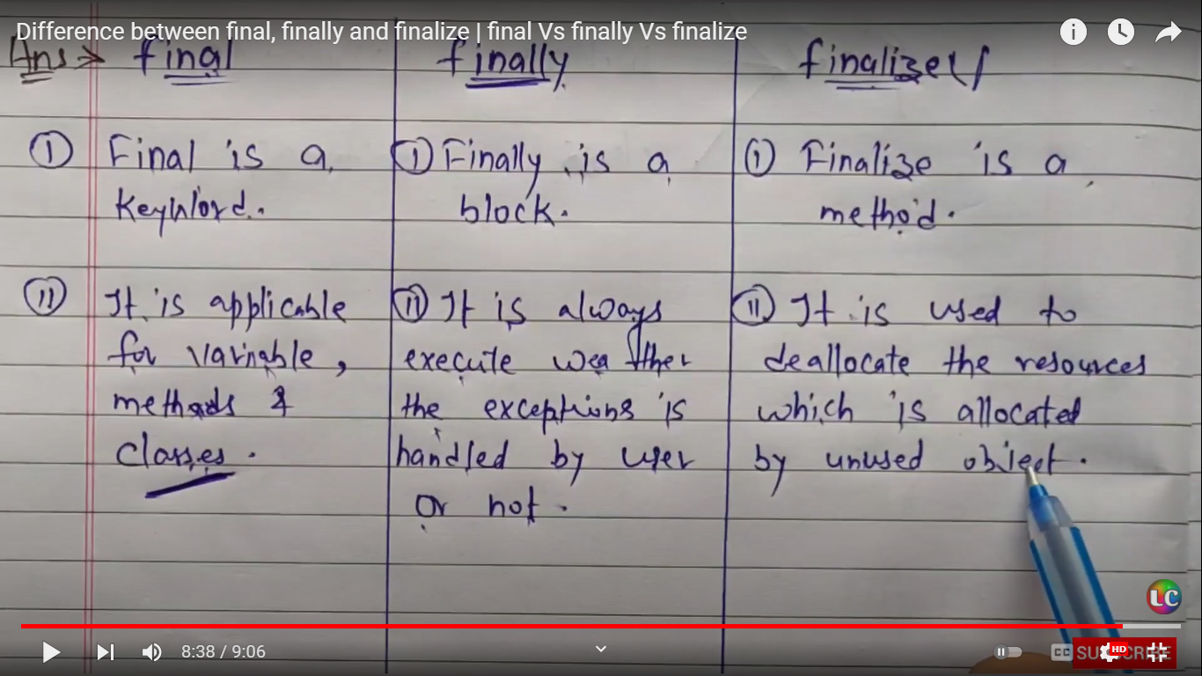

What is hashmap

* Java HashMap contains values based on the key.
* Java HashMap contains only unique keys.
* Java HashMap may have one null key and multiple null values.
* Java HashMap is non synchronized.
* Java HashMap maintains no order.
* The initial default capacity of Java HashMap class is 16 with a load factor of 0.75.

Wait

driver.manage ().timeouts ().~~implicitlyWait~~(15, TimeUnit.SECONDS)

What is CI, CD?

Continuous integration (CI) is practice that involves developers making small changes and checks to their code.

[Continuous delivery](https://www.synopsys.com/glossary/what-is-continuous-delivery.html) (CD) is the automated delivery of completed code to environments like testing and development.

What is Assertion?

Assertion determines the state of the application whether it is the same what we are expecting or not. If the assertion fails, then the test case is failed and stops the execution. To use the Assertion in Web Driver, you need to download the Testng jar file and add it to the eclipse.

10 .How do we find no of link on webpage??

List<WebElement> allLinks = driver.findElements(By.tagName("a"));

6. Diff bet assertion and verification.

Assert: If the assert condition is true then the program control will execute the next test step but if the condition is false, the execution will stop and further test step will not be executed. whereas, Verify: There won't be any halt in the test execution even though the verify condition is true or false

* + 1. Importance of screenshot

In Selenium, you can locate the elements, perform actions, record test cases, etc. Taking screenshots at each step of the test process **provides a visual record of the use case that can help in troubleshooting when the test fails**

What is difference between rank and dense rank?

SELECT name,company, power,

RANK() OVER(ORDER BY power DESC) AS PowerRank

FROM Cars

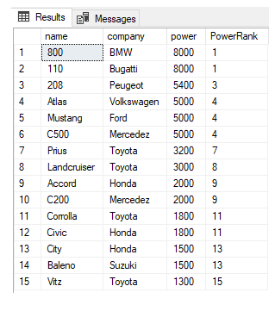 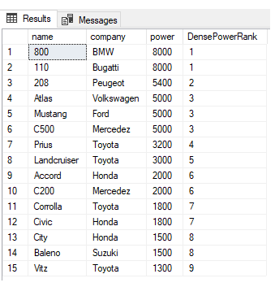

RANK Function DENSE_RANK Function

Aware about ETL testing? == extracts, transforms, and loads

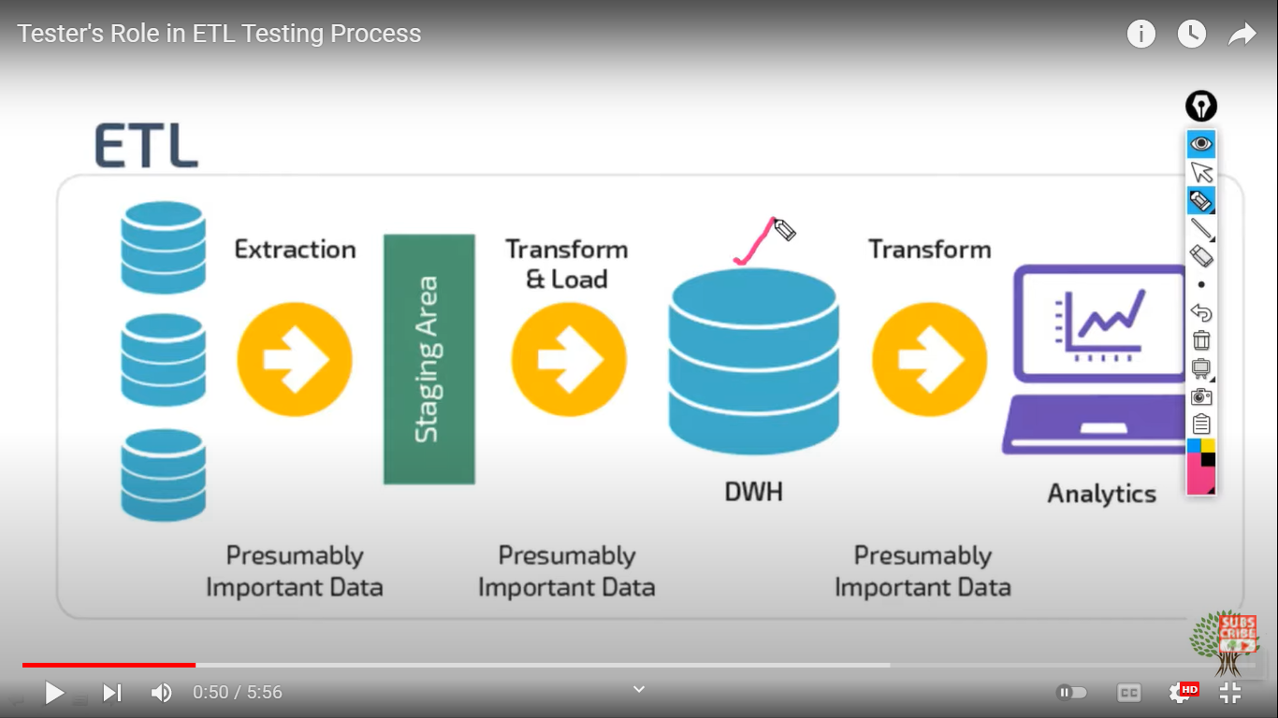

Difference between where and having ?

1. **WHERE Clause:**   
   WHERE Clause is used to filter the records from the table or used while joining more than one table.Only those records will be extracted who are satisfying the specified condition in WHERE clause. It can be used with SELECT, UPDATE, DELETE statements.
2. **2. HAVING Clause:**   
   HAVING Clause is used to filter the records from the groups based on the given condition in the HAVING Clause. Those groups who will satisfy the given condition will appear in the final result. HAVING Clause can only be used   
   with SELECT statement.

How to find out duplicate in database?

SELECT OrderID, COUNT(OrderID)

FROM Orders

GROUP BY OrderID

HAVING COUNT(OrderID)>1

1. Components of bug report
2. Title/Bug ID
3. Environment
4. Steps to reproduce a Bug
5. Expected Result
6. Actual Result
7. Visual Proof (screenshots, videos, text) of Bug
8. Severity/Priority

“**A mistake in coding is called Error, error found by tester is called Defect, defect accepted by development team then it is called Bug**, build does not meet the requirements then it Is Failure.”

## Test Harness in Software Testing

**Test Harness in Software Testing** is a collection software , test data ,stubs, drivers and other supporting tools required to automate test execution.

Test harness contains all the information needed to compile and run a test like test cases, target deployment port(TDP), source file under test, stubs, etc

When to stop testing?

1) Stop the Testing when deadlines like release deadlines or testing deadlines have reached

2) Stop the Testing when the test cases have been completed with some prescribed pass percentage.

3) Stop the Testing when the testing budget comes to its end.

4) Stop the Testing when the code coverage and functionality requirements come to a desired level.

5) Stop the Testing when bug rate drops below a prescribed level

6) Stop the Testing when the period of beta testing / alpha testing gets over.

What if software is so buggy that it can't be tested at all?

* If the software is so buggy, the first thing
* we need to do is to report the bugs and
* Categories they based on Severity.
* If the bugs are critical bugs then it severely
* affects schedules and indicates deeper problems
* in the software development process.
* So you need to let the manager know about
* the bugs with proper documentation as evidence.

8. Difference between findelement and findelemennts

|  |  |
| --- | --- |
| **findElement** | **findElements** |
| Returns the first matching web element if multiple web elements are discovered by the locator | Returns a list of multiple matching web elements |
| Throws **NoSuchElementException** if the element is not found | Returns an empty list if no matching element is found |
| Detects a unique web element | Returns a collection of matching elements |